MAY 2019

It has been a busy month with many exciting activities happening such as the highly successful Biggest Morning Tea which happened On Wednesday 15th May, The recent grand opening of our new wing on Friday 10th May just to name a few exciting events that have happened , In this newsletter are some highlights from this month. We hope you enjoy reading this edition.
Hope you have a good month =)

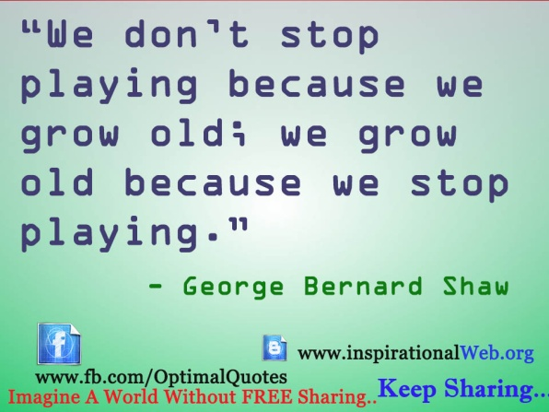

The Day was a huge success with the highly popular Plant and trading stores providing everyone with bargains with all proceeds going to a good cause, there were also Raffles and a lucky door prize, prizes were generously donated by various community organizations and individuals. The kitchen staff along with volunteers provided delicious food and drinks throughout the morning from their newly renovated kitchen. Everyone had an enjoyable day and gave nothing but praise to all involved with making the day the success it was. We also received good feedback such as “A wonderful experience, an example of the residents generosity, always lovely to be here all for a good cause” from Yvonne Everett, one of our many hardworking volunteers involved with organizing in the lead up to the event and assisting on the day. We look forward to seeing everyone back in 2020 where we’ll do this all again for a good cause.
BREAKDOWN OF PROFITS RAISED- BIGGEST MORNING TEA 2019

RAFFLE: $608.55
PLANTS: $153.00
TRADE TABLE – OUTSIDE: $186.00
TRADE TABLE – INSIDE: $278.90
DONATIONS (BOX) : $290.70
RECEIPTED DONATIONS: $608.00
TOTAL FUNDS RAISED: $ 2125.15

WINNERS OF RAFFLE- BIGGEST MORNING TEA 2019:

1st Elwin Drew
2nd Viv Wellington
3rd Pauline Corcoran
4th Chris Wilkin

On Friday 10th May we had the grand opening of our highly anticipated 20 bed extension by the Federal member for Calare Andrew Gee MP, this was well attended and the delicious food provided by the hardworking kitchen staff was appreciated by all, A big thank you to the cleaning staff for all your efforts in the lead up to the event.

In this section we will be interviewing a staff member from each department in your home about what their role is and other facts about them. This month we will be interviewing Emily Falson our Food Services Manager.

- What is your role in the kitchen?
Food Services manager- Responsible for the everyday nourishing and feeding of residents and everything to do with food such as ordering. Staff training, front of house service

- How long have you been in this role?
11 months

3. What do you enjoy most about your role?
When the residents give feedback regarding food and ensuring they’re happy with what they’re getting, A great catering team to work with.

- What is the most challenging part of your role?
It’s a Fast paced environment and ensuring the residents get their food on time for every meal.
- What Inspired you to pursue this career?

A passion for food and a passion for great service. What a privillage to deliver food to our residents.

Biggest Morning Tea- Wednesday 15th May 2019

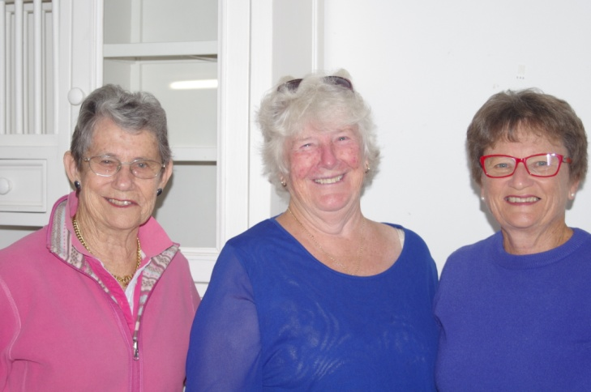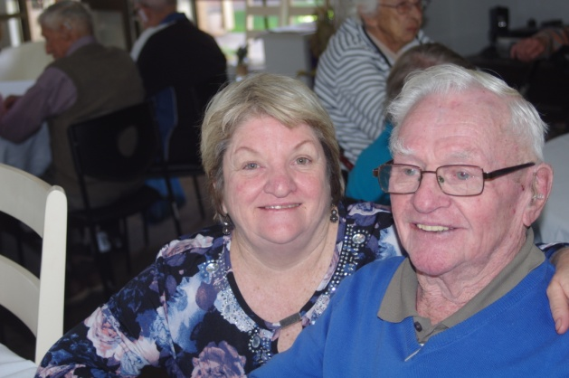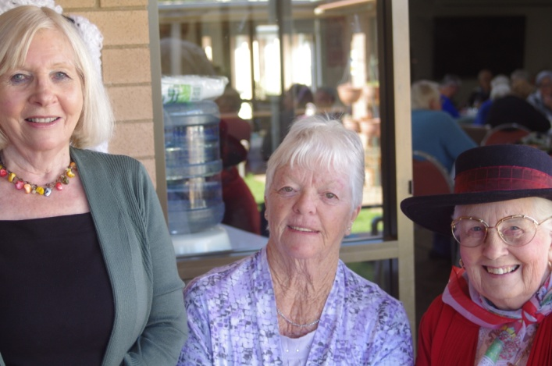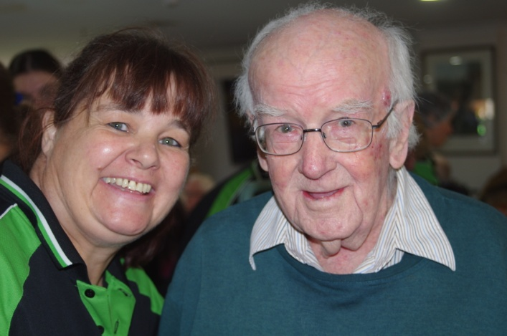

Photos taken by: Dale Elliott- Newsletter Creator

BIRTHDAYS:

Happy Birthday to everyone who has/ is having a birthday this month, hope it was/ is a good one.

CONTACT DETAILS/ MANAGEMENT

CEO: Debra Wells
Newsletter Creator: Dale Elliott
Office: 02 6845 3088
Fax: 02 6845 3087
Address: 127-137 Whiteley Street Wellington, NSW 2820
Facebook: Maranatha House
Website:
Email: admin@maranathahouse.com.au

The Board of Directors Include:
- Chairman: Mr. John Trounce, Joined 2006 Occupation: Farmer / Grazier
- Vice Chairman: Mr. Terrance Frost, Joined 2011, Occupation: Retired School Principal
- Treasurer: Mr. Richard Ivey, Joined 2011, Occupation: Accountant
- Secretary: Ms Vivien Wellington, Joined 2015, Occupation: Real Estate Agent
- Directors: Ms Rae Batho, Joined 2008 (Occupation - retired Club Sec/Mgr) ,
- Mr. Donald Chisholm , Joined 2011 (Occupation - Hotel Mgr),
- Mr. Ross Conn, Joined 2012 (Occupation - Farmer),

Mr. Sam Lemon, Joined 2012 (Occupation - Small business owner),

Mr. Alistair Thompson Joined 2013 (Occupation: School Teacher).
The Board meet once a month – In the board room

