AUGUST 2019

Welcome to this month’s newsletter which is jam packed full of many exciting events that have happened, we hope you enjoy reading the highlights from each event. We have also attached to this newsletter a survey which you’re invited to fill out regarding your care and any other feedback you have for us.

BIRTHDAYS:

Val Gersbach 12th August

Graham Morrow 14th August
Patricia Cassidy 23rd August

Some of our residents have been busily doing creative art, here are some recent highlights from a session held in July.
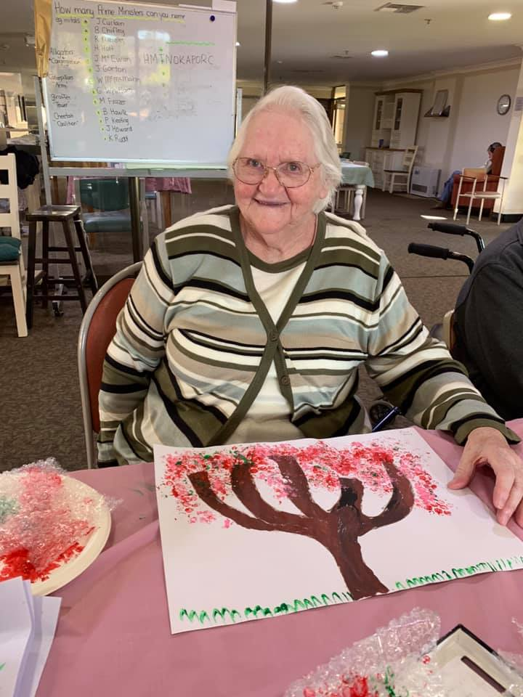
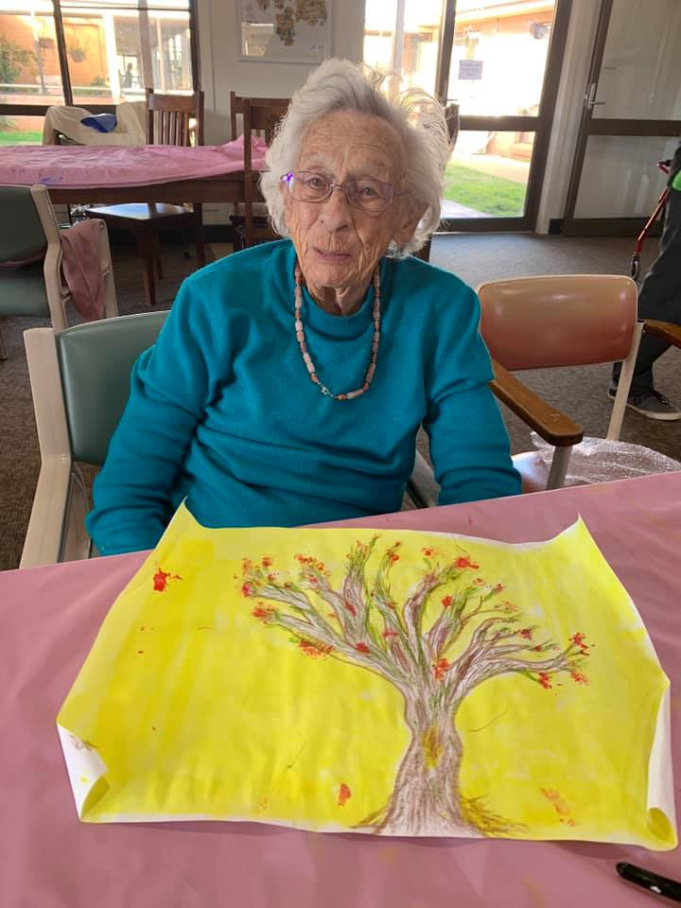

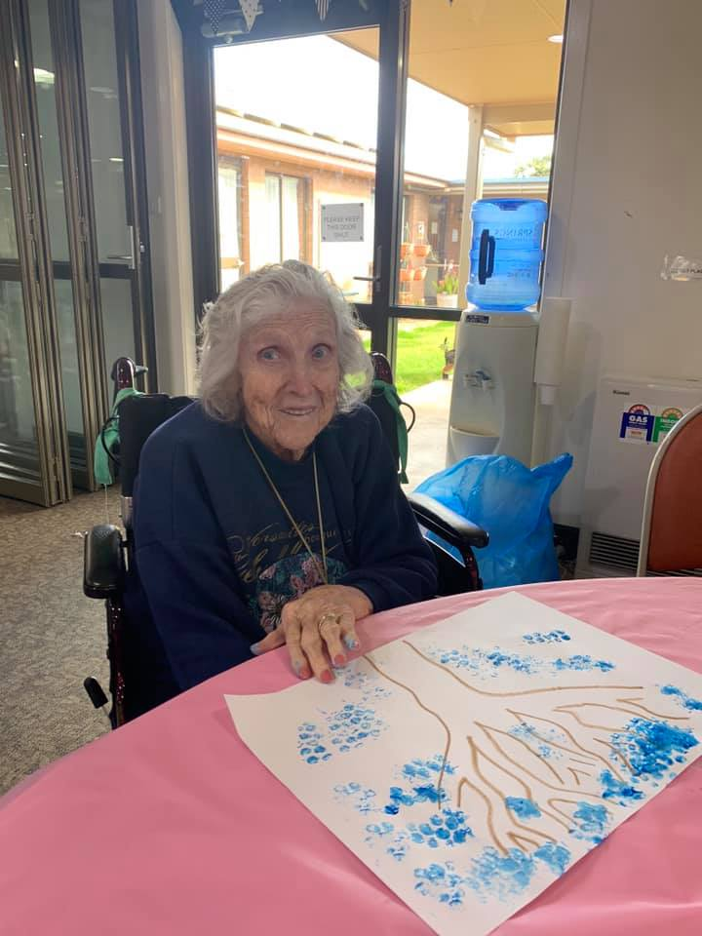
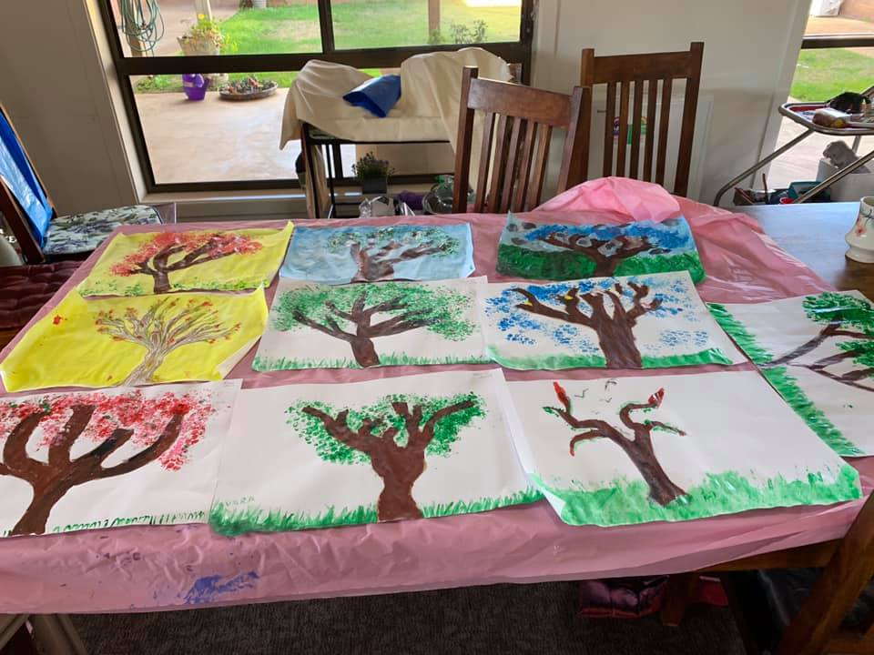

If you have any big Coffee jars at home, please feel free to bring them in as we would like to use them as vases for flowers.

If you would like to contribute anything to the newsletter such as notices, Buy, Swap & Sell, stories anything, please let a staff member know and they’ll pass it on for Dale to place in the newsletter. Dale is available 9am until 5:30pm Wednesday’s in the office for if you would like an appointment with him to discuss anything for the newsletter.

Congratulations to Khan one of our staff members who received employee of the month in July

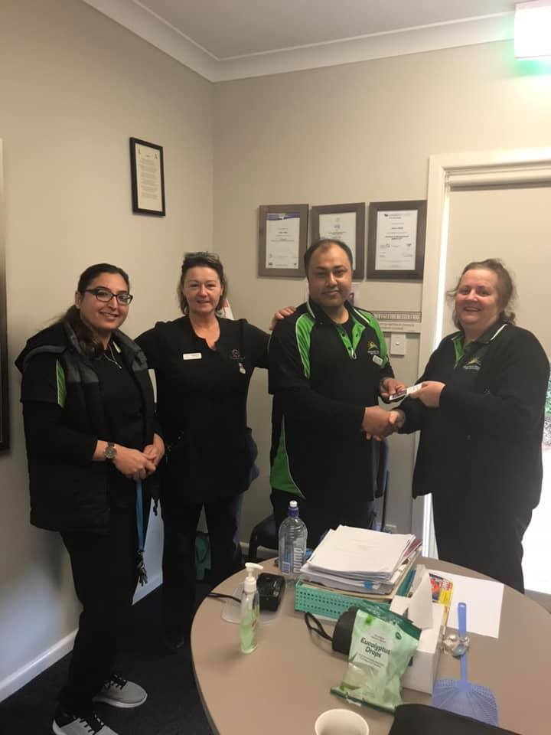

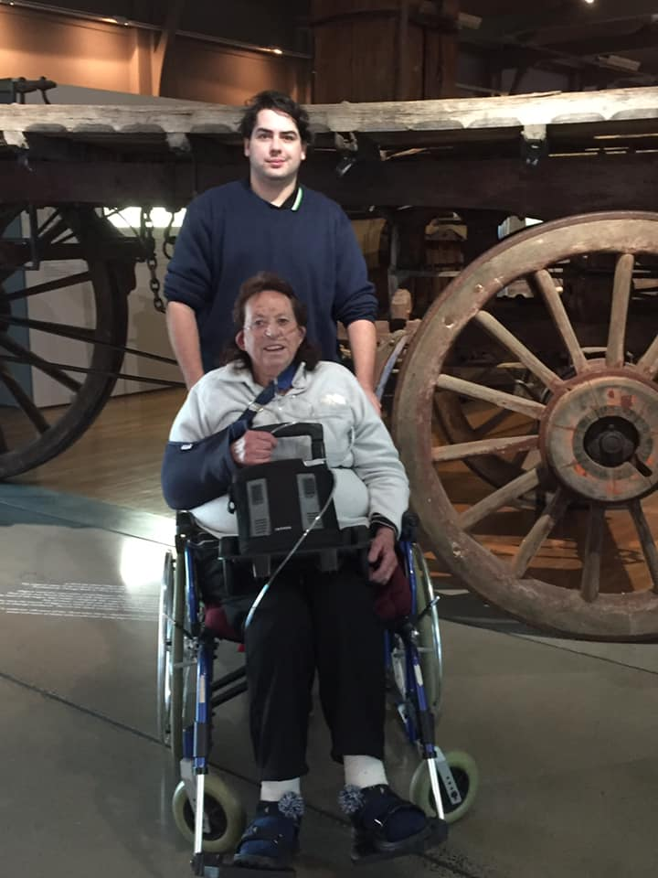
In June the ESST team took a group of residents to the Western Plains Cultural Centre in Dubbo, the residents had a great time and here are some photos from the day:
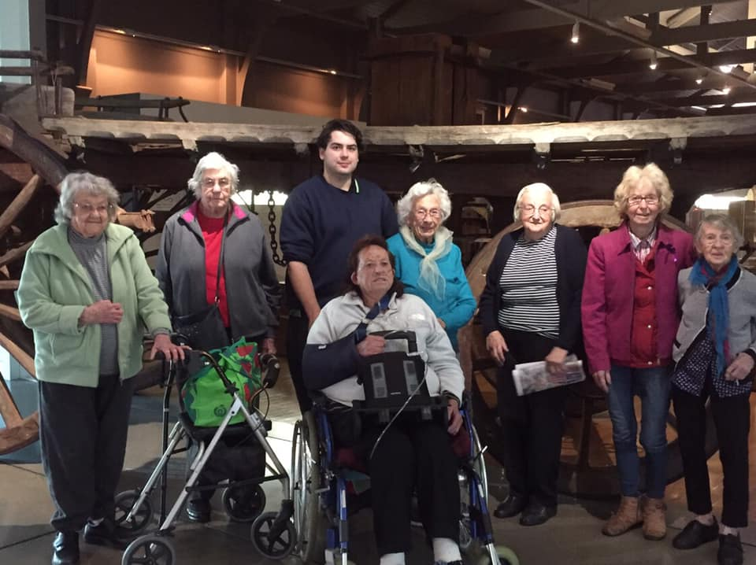

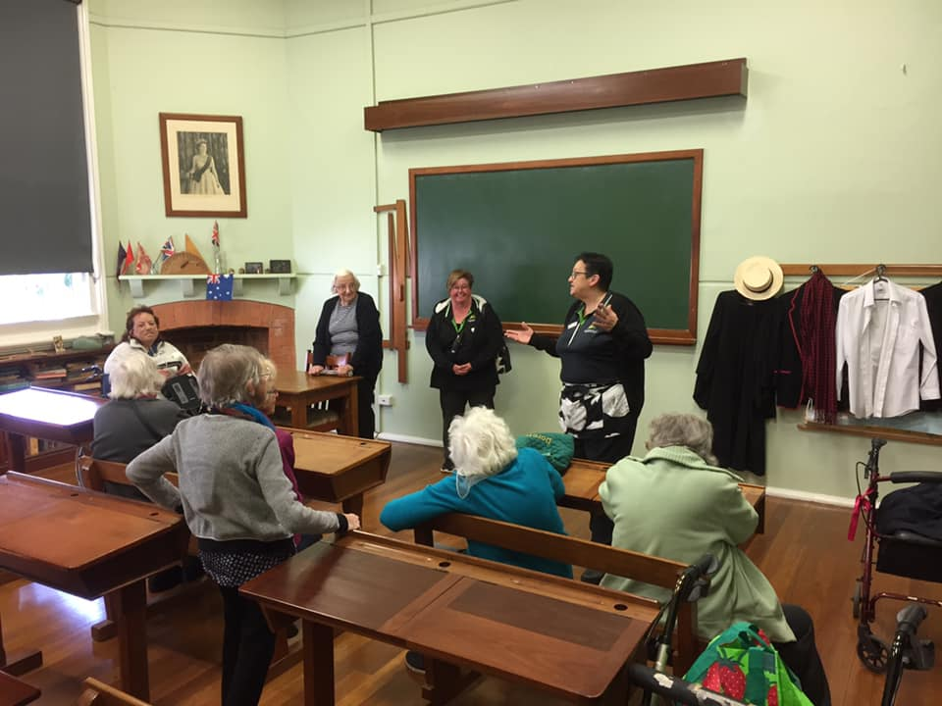
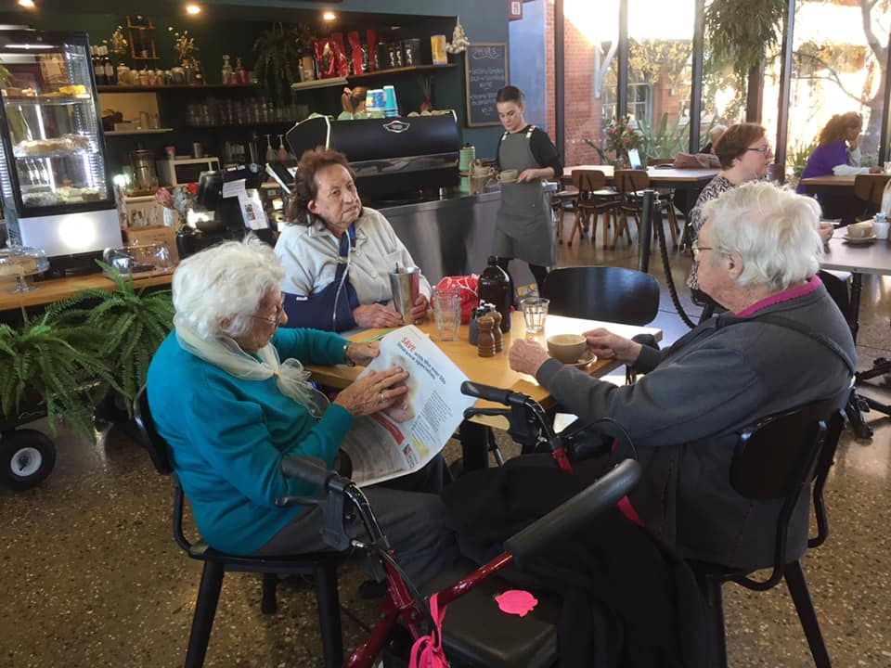

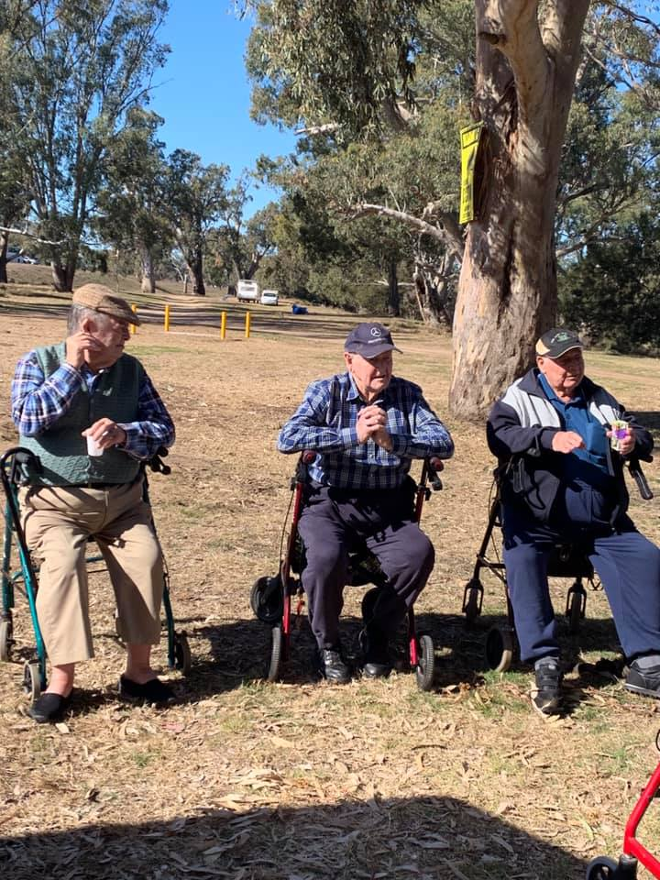
In July some of our residents enjoyed a picnic at Ponto Falls, the weather was great for everyone and lots of fun had, here are some highlights from the day.
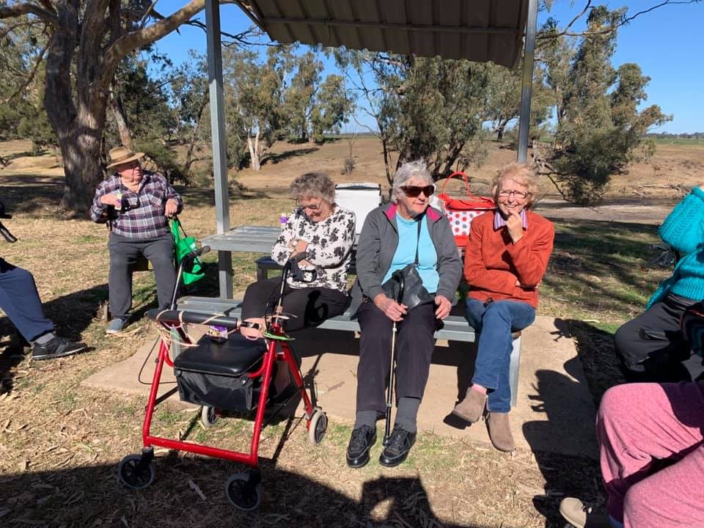

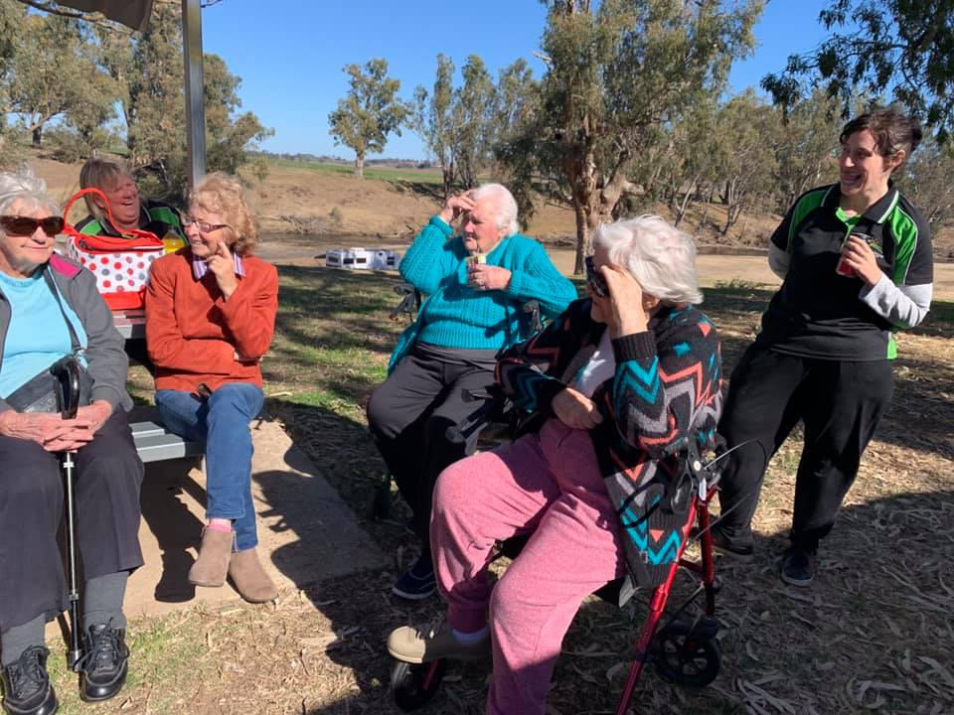

This month as part of our Continuous Quality Improvement Plan, our library will be delivering CD’s and Talking Books to our residents, also two additional CD players with Headphones have been purchased.

Maranatha House and the NALAG Centre for Loss & Grief invite you, your loved ones and Family to our Remembering Ceremony which will be held on Wednesday 21st August 2019 11am at Maranatha House, 127-137 Whiteley St Wellington. There is no cost Light Lunch and refreshments will be provided, RSVP by 16th August 2019, for more information contact Maranatha House 6845 3088.

MANAGEMENT CONTACT DETAILS
CEO: Debra Matheson
Administration Assistant: Dale Elliott
Office: 02 6845 3088
Fax: 02 6845 3087
Address: 127-137 Whiteley Street Wellington NSW 2820
Facebook: Maranatha House
Website: www.maranathahouse.com.au
Email: admin@maranathahouse.com.au
The Board meets once a month in the boardroom
The Board Of Directors Are:
Chairman: John Trounce Director: Donald Chisholm
Vice-Chairman: Director: Ross Conn
Secretary: Viviene Wellington Director: Sue Knowles
Treasurer: Richard Ivey Director: Alistair Thompson
Director: Peter Lewsam Director: Rae Batho

Intergenerational Childcare Committee

Terry Frost Alistair Thompson

Rae Batho Megan Smith

Mary Henderson Dixie Robinson

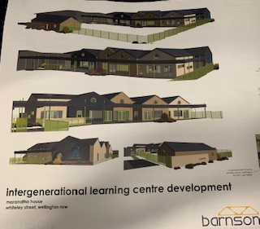

MARANATHA HOUSE HAS DEDICATED AUGUST
TO FAMILY CARE MEETINGS

If you are interested in booking a Family Care Meeting with us we will be available every Tuesday in August 10-12pm and 2-4pm. We can be contacted on (02)68453088 to make an appointment. If you are unable to attend Maranatha House please feel free to fill in the questionnaire and return it to us via e-mail or post.

What is important to you and your loved one about moving in to Maranatha?

What are your expectations of us?

Would you like to keep your connections within the Community and how can we help?

Have you any messages that can be passed on to these Departments?
Please feel free to use this a prompt for any enquiries you may have

Laundry:________________________________________________________________________________________________________________________________________________________________________________________________________________________________________________________

Cleaners:________________________________________________________________________________________________________________________________________________________________________________________________________________________________________________________

Catering:________________________________________________________________________________________________________________________________________________________________________________________

Maintenance:____________________________________________________________________________________________________________________________________________________________________________________________________________________________________________________

Personal:_______________________________________________________________________________________________________________________________________________________________________________________________________________________________________
Carers:_______________________________________________________________________________________________________________________________________________________________________________________________________________________________________________________

RN’s________________________________________________________________________________________________________________________________________________________________________________________________________________________________________________________________________________________________________

Management:____________________________________________________________________________________________________________________________________________________________________________________________________________________________________

Thank you for your participation

