JULY 2019
The weather may be getting cooler outside but the excitement continues with many great activities happening within your home. We hope you enjoy reading this newsletter. In this newsletter are photos from Enid and Laurel’s birthday celebrations which were held in June, if you have something you would like to contribute to the newsletters please come and see Dale, he is located in the admin office Wednesday’s from 9am until 5:30pm.

BIRTHDAYS:

Pauline Corcoran 9th July
John Drew 10th July
Anne Donovan 13th July
Mick Wise 29th July

Linda one of our Emotional & Spiritual Support Team members, returned to Maranatha in 2016, Linda has come back to Maranatha because of the great changes that have happened and to be a part of this wonderful growing organisation. Recently the team went with some of the residents to see Foster & Allen at the Dubbo Regional Theatre, the residents were happy to see the show some had tears of happiness, They also went to Ma Bakers Tonic the WATS Production at the Wellington Soldiers Memorial Club, recently they attended Australia’s Biggest Morning Tea which was held in the East Wing Lounge room where the residents stall raised $152.00 with pot plants they designed which contributed to the significant amount raised. There are many new and exciting events coming up such as Mathew Dickerson a new poet coming to visit once a fortnight, Sam Dorin will also visit once a fortnight to do Facial Massages. On the Monday of the Queen’s birthday long weekend, Barry Dickerson and Mick Austin provided excellent entertainment for the residents, than in October the residents will be going to the Dubbo Regional Theatre again to see Dances of the Fredastair Era. The team are also in the process of organising a Maranatha Cultural Day with a date to be advised, if you or your family have anything from your country of Origin please come and see Linda. If anyone has any big coffee jars you no longer wish to use the team would love to have them to use as vases for flowers.

During June, Enid Parkes celebrated her 90th Birthday here are some photos from the day.

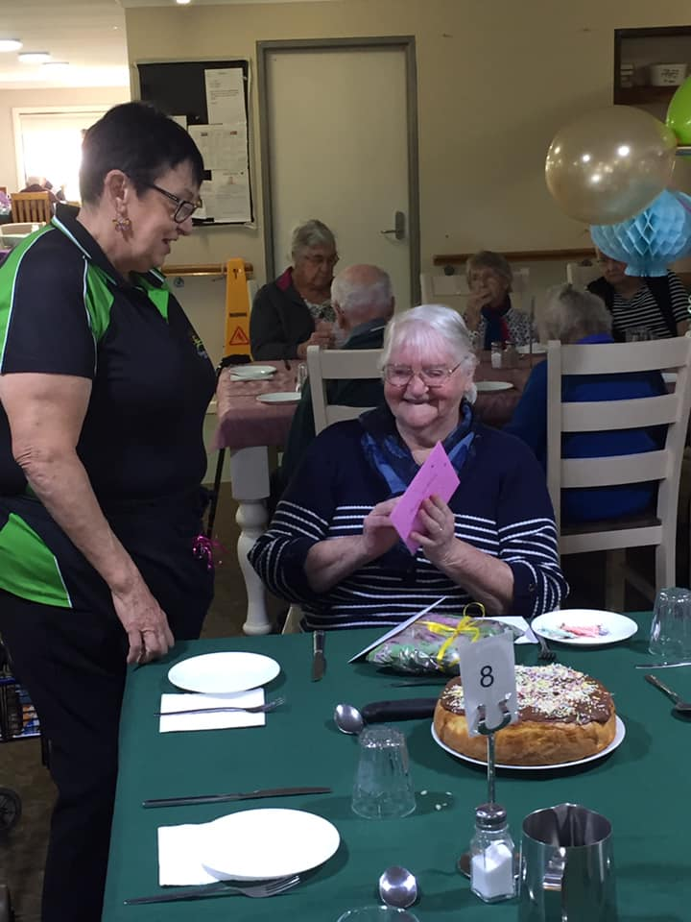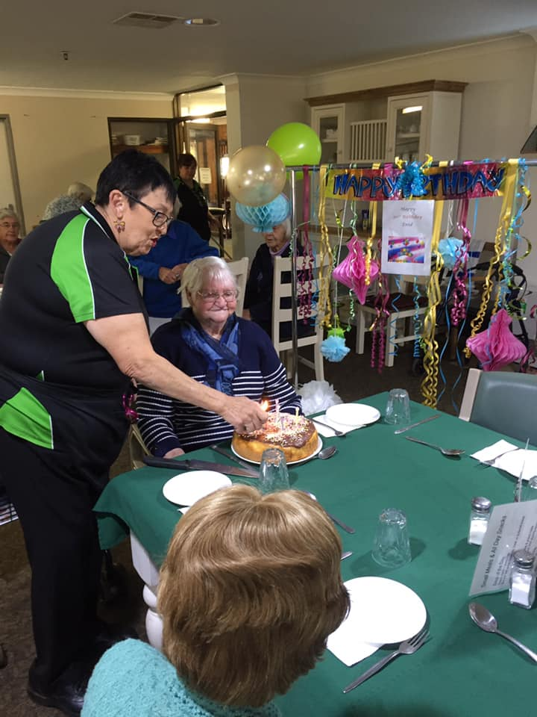

The Birthday celebrations continued for June with another of our residents, Laurel celebrating her birthday surrounded by family and friends, here are a few photos from the day:

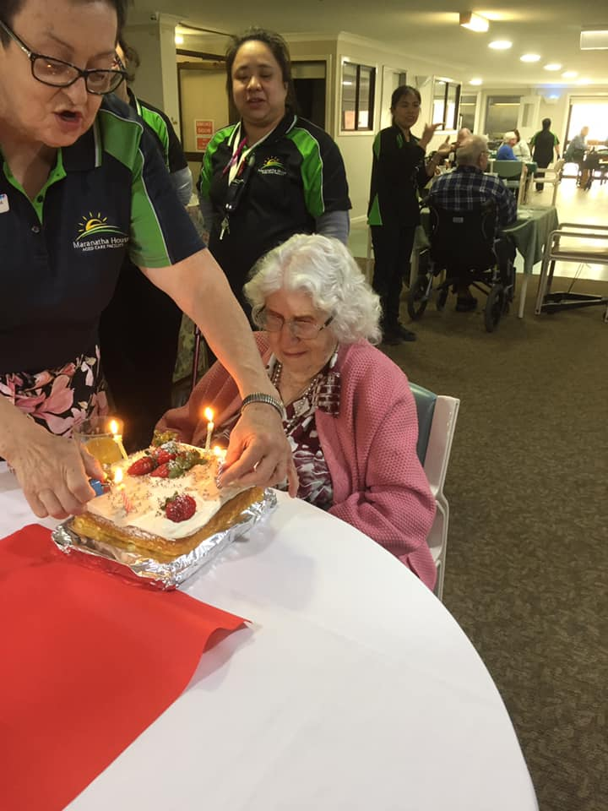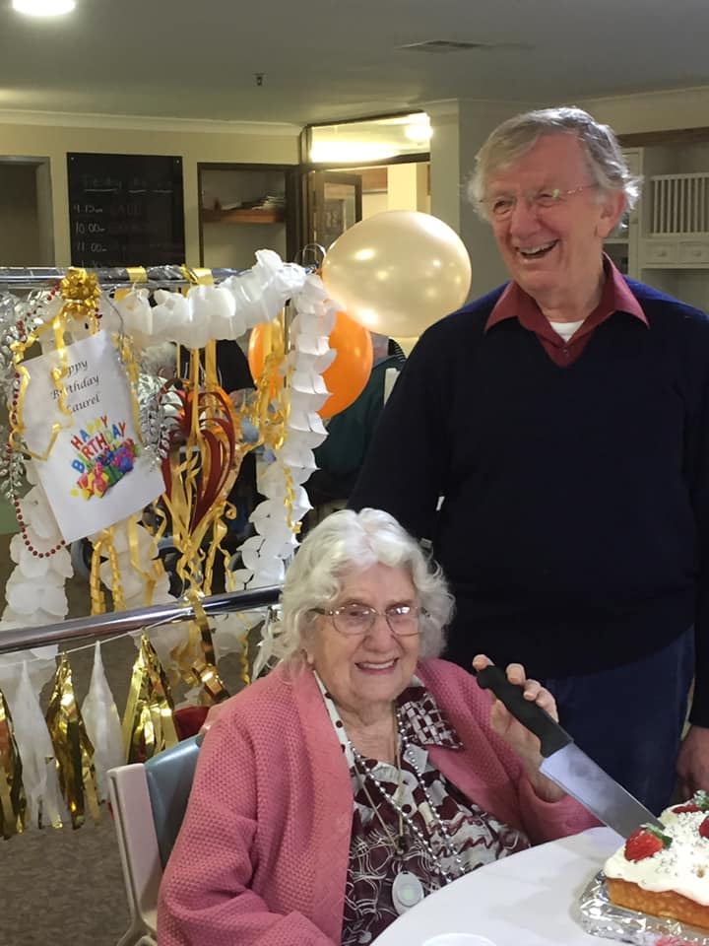

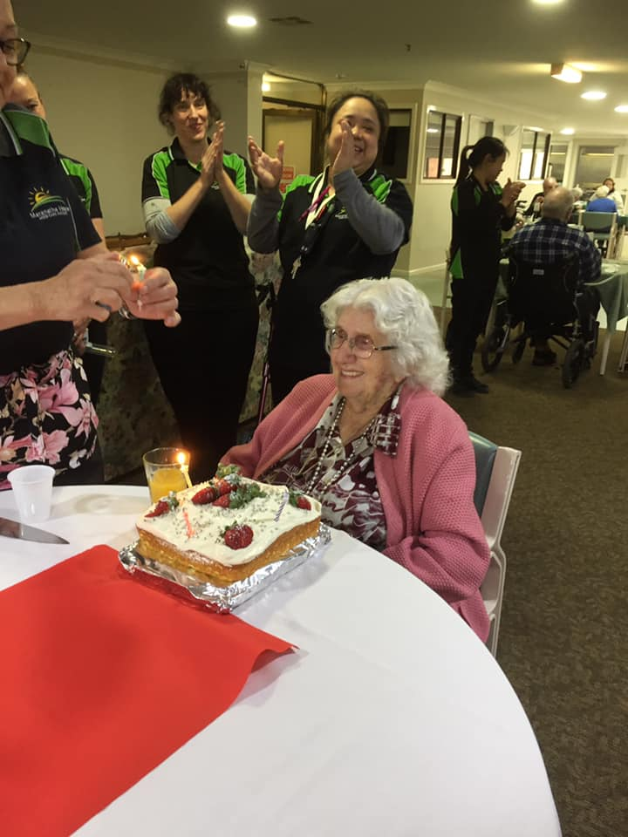

We recently had Mathew Dickerson who is a poet come to visit us, this was enjoyed by all who attended here’s a few photos from the day:

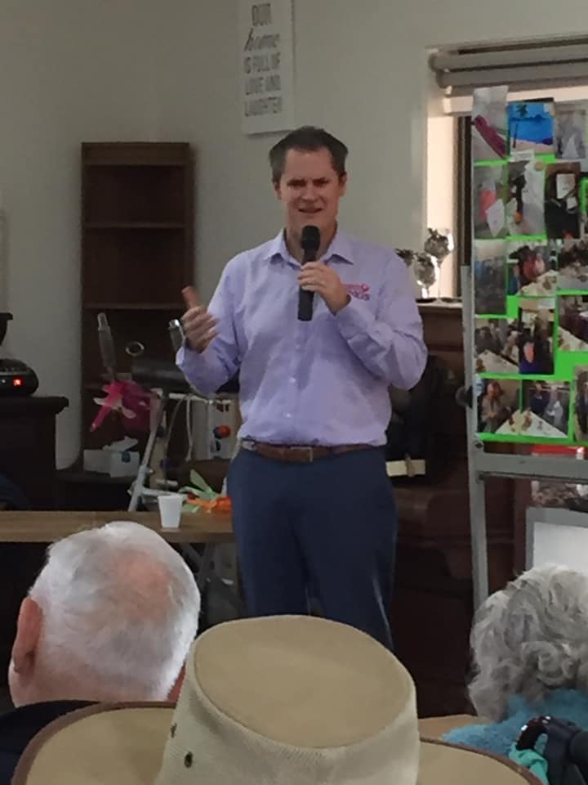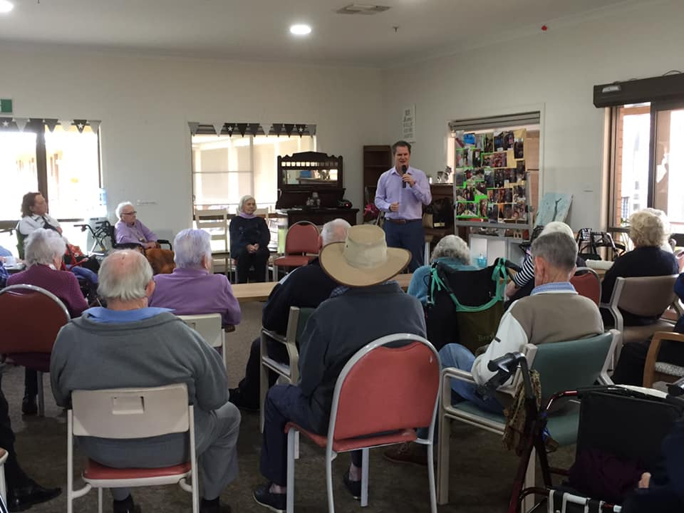

MANAGEMENT CONTACT DETAILS

CEO: Debra Matheson
Administration Assistant: Dale Elliott
Office: 02 6845 3088
Fax: 02 6845 3087
Address: 127-137 Whiteley Street Wellington NSW 2820
Facebook: Maranatha House
Website: www.maranathahouse.com.au
Email: admin@maranathahouse.com.au
The Board meets once a month in the boardroom
The Board Of Directors Are:
Chairman: John Trounce Director: Donald Chisholm
Vice-Chairman: Terence Frost Director: Ross Conn
Secretary: Vivien Wellington Director: Sam Lemon
Treasurer: Ms Rae Batho Director: Alistair Thompson
If you would like to contribute something to the newsletters please feel free to drop it off to Admin for Dale to place in Newsletter. Thank You =)

